Strava Art for beginners
There are multiple methods of designing and recording your run/walk/cycle that will work better with certain fitness trackers, phone apps or user preferences. We do not in any way endorse any method over another, use what works for you. This is just an example of one method that should work for most people.

Planning
Download the free “MapMyFitness” App onto a smart phone. This is available for Android and Apple and is free with adverts or you can pay a few dollars to get rid of the ads.
Set up an account and log onto the website on your computer (not your phone).
Select “ROUTES” and “Create Route.” Choose the map location where you want to run. In route details give your route a name and select if you are running or cycling it (this seems to change which roads/paths it snaps to). Ensure “save to phone” is selected.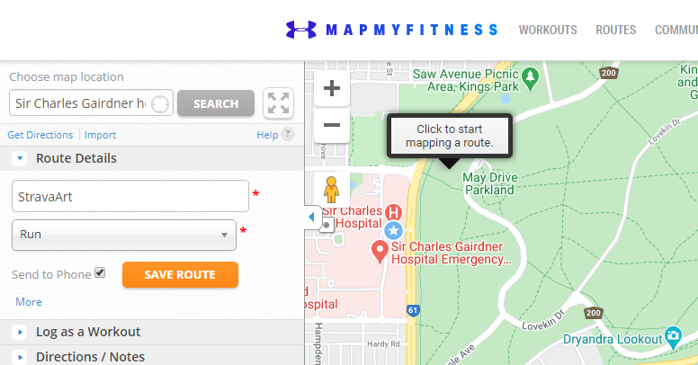
Click on points along your route and it should update your map, sticking to the paths. If you don’t like a section you can undo and add another point to force it to detour. It tells you how far your route is to prevent you planning marathons without meaning to.
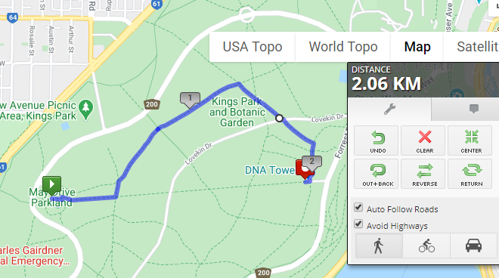
When you are happy click on SAVE ROUTE in the Route Details window.

Completing your route and recording it
Open the MapMyFitness app on your phone, select LOAD ROUTE and select your new route.
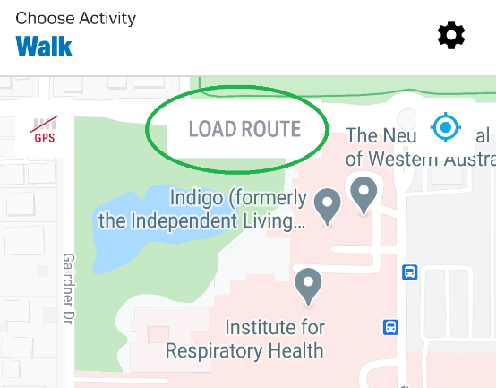
Get to the start point and click Start Route, ensuring GPS is enabled. If you want to get fine details it might help to turn off power saving mode to ensure you have a good GPS signal at all points.
As you travel the App will show you your planned route and display your actual track. It doesn’t give you voice prompts to turn left here so you may need to check your phone occasionally to see if you are on the correct path.
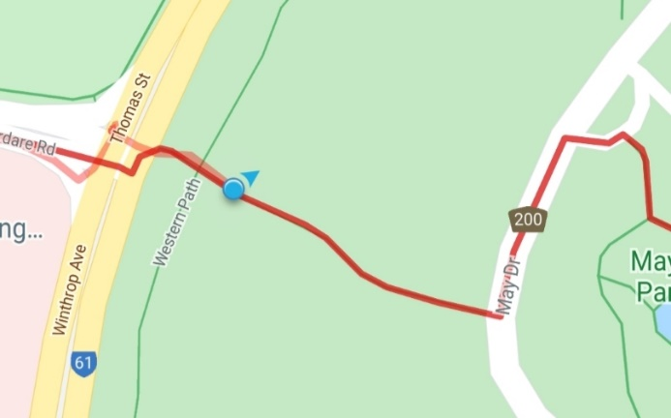
When you finish your run/walk/cycle save the workout. You will then be able to screenshot your actual path along with your speed/distance etc.
